A White Paper

Health Plans:
Affordability
And
Sustainability

Frank M. Stichter
Managed Healthcare Professional

2015

Annual Increases or Annual Savings
Frank M. Stichter, MHP

With health care costs continuing to steadily rise, at the end of the day it’s really a matter of Affordability and Sustainability. We can’t simply keep on doing what we’ve been doing historically – raise employee contributions and/or raise deductibles, copays, and out of pocket expenses in the plan. We need to deploy new ideas, techniques, and programs to effectively stem the tide of annual increases and turn them into decreases. We must challenge the status quo.

First…Consider These Surveys Regarding Affordability

Kaiser Family Foundation Health Benefits Survey

This survey recently reported that annual premiums for employer-sponsored family coverage climbed nearly 4 percent this year to top $16,000 for the first time. The cost of single coverage rose almost 5 percent. Worker wages, meanwhile, climbed nearly 2 percent on average.

Wages have climbed about 31 percent since 2003. But the average contribution a worker makes to family health insurance has jumped 89 percent. Premiums have increased nearly three times as fast as wages and inflation in the same period.

MetLife Report

According to MetLife’s 11th Annual Study of Employee Benefits Trends, uncertainty around health care reform is not only affecting human resource departments, it’s also having a direct impact on employees. Over half (54%) of those employees are very concerned about having access to affordable health insurance. Employers can help address workers’ concerns and increase productivity by enhancing their benefits program with voluntary supplemental health products, wellness programs and by increasing benefits communications.

The MetLife study found 61% of employees are concerned about having enough money to cover out-of-pocket medical costs that are not covered by health insurance such as premiums, deductibles, co-pays and travel. These concerns are compounded by other financial concerns facing employees: 55% of employees report they worry about meeting their monthly living expenses and three out of four employees who are very worried about meeting out-of-pocket medical expenses don’t have a three- month salary saving cushion to tap into.

National Business Group on Health Survey
The cost of providing employee health care benefits at the nation’s largest employers is projected to increase by an average of 7 percent in 2014, according to a survey by the National Business Group on Health.
The survey, based on responses from 108 of the nation’s largest corporations, also found more companies plan to offer workers a consumer-directed health plan as their only health benefits option in 2014. CDHPs, because of their high deductibles, are less expensive than preferred provider organizations and other more traditional plans.

Healthcare costs will continue to increase at a rate that is not commensurate with increases in wages.
The addition of Essential Health Benefits, elimination of pre-existing conditions, changes in eligibility, and other requirements of PPACA will help fuel these increases in the future along with historic trend.

As a result, increases in employee contributions, or cost shifting benefits with higher deductibles, CDHPs, copays, etc. are not sustainable for employees. With significant deductions from a paycheck, and more out of pocket spending - how high is the breaking point?

Next…Consider Sustainability

The Rule of 72
The Rule of 72 is a mathematical equation to calculate the number of years that is takes money to double. As it relates to your insurance premium expense, at a given yearly percentage increase, the result will determine how many years it will take to double the cost. You will always divide the premium increase into the Number 72, and what results is the number of years it takes for the premiums to double, assuming the same static increase every year.
- Example: When the premium increase is 9 percent per year, one divides 72 by 9; 8 results, so that in 8 years the insurance premiums will have doubled.

So while a group may think that an annual single digit increase is attractive, sprinkle in a few years with double digit increases, and in a rather short period of time the expense has doubled. You may have even had several benefit changes over that period as well, so that the value of the plan has diminished at the same time. Without those changes, e.g. increases in deductibles, the time it would have taken for premiums to double is even shorter.

If your plan costs have already doubled looking back in time, how long before they double again?

So what is a group to do? What can be done to make a plan affordable and sustainable for the long haul?

The Solution – The First Step

A thorough evaluation of a plan, essentially an Audit or Analysis, is needed to investigate and examine areas of opportunity within the plan without changing benefits or cost shifting to employees. Categorically the first area to examine: Summary Plan Description / Plan Document / Contracts

The SPD and Plan Document should be reviewed to not only assure compliance with PPACA and other laws and mandates, but to review it in detail regarding:

- Eligibility determinations and definitions (not just FTE hours)
- Benefit provisions and definitions
- Exclusions
- Provider definitions
- Out dated language provisions
- Coordination of Benefits
- Specialty management coverage
- Disease/Risk Management plans
- Intent

The Department of Labor has ruled that unless something is excluded in your plan – it is a covered expense, regardless of the intent of the Plan Sponsor. It is imperative that the SPD reflect the intent in detail so there is no confusion, misunderstanding, or payment of an expense that should not be covered, or on an ineligible member.

The Solution – The Second Step

The second area to examine is claims data. In order to examine the claims data, a robust claims reporting system is needed, specifically to review the following:

- Dependent audit
- Identification of population with chronic conditions
  - Clinical Compliance to AMA guidelines
- Large case management opportunities
- Diabetes management program
- Oncology management program
- Large Hospital Bill review
- PPO network discount/pricing methodology evaluation
- Prescription Drug Costs
- Disease/ Risk Management opportunities
- Telemedicine applications
- On-Site and Near-Site Clinics
- Verification of Renewal Methodology and substantiation of renewal rates
- Specialty networks
- Collaboration with Community Partners and Providers

Without a reporting system capable of data analytics and digging into the detail, it’s impossible to understand trends and patterns of utilization and determine what possible solutions and strategies to consider. In some cases, your administrator has the capability to run the reports, they simply need to know what specific data to furnish or how to sort it. All data can be aggregated and de-identified. A few basic sample screen shots are below:

Identification on Disease States is important to understand the risks in your group and how costs compare to statistical norms. Each of these conditions has additional drill down capabilities, e.g. Hypertension and Diabetes.

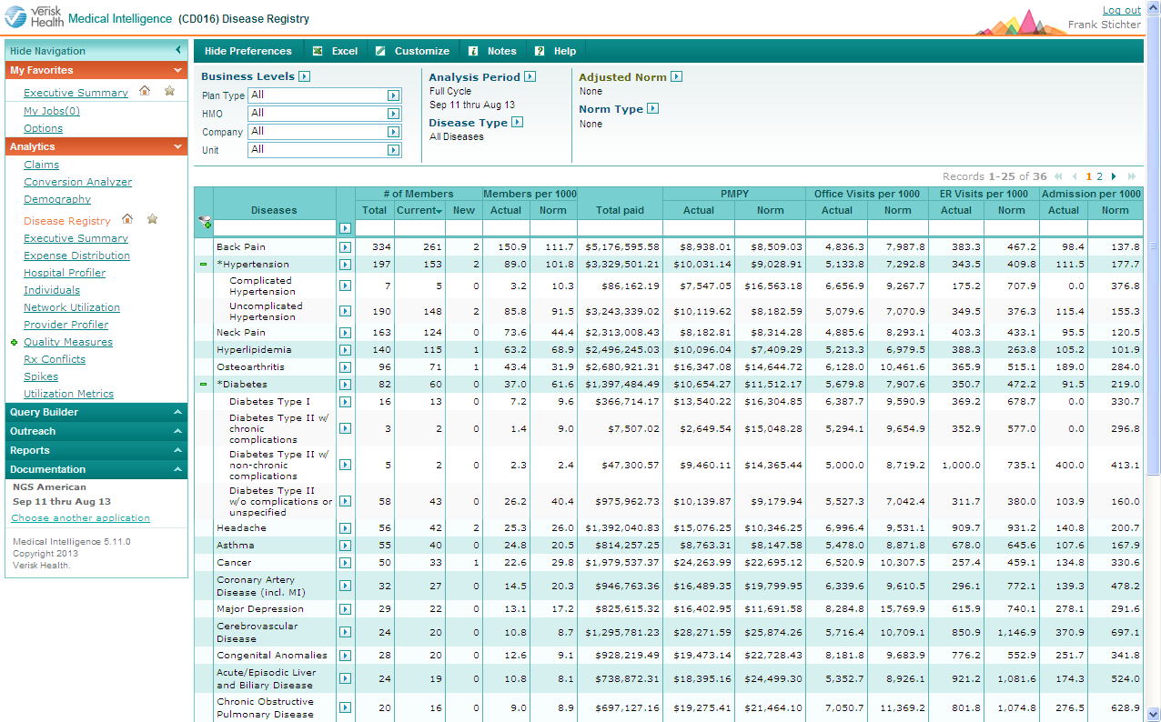
While all of the data is aggregated, you are able to understand the magnitude of your Chronic Conditions.

Drill down capabilities are necessary to effectively identify a groups ‘problems’ with Chronic Conditions and can be addressed in a variety of ways.

As you can see, you are also able to know the level of clinical compliance to AMA Guidelines and HEDIS measures.
617 actual Quality and Risk Measures for Chronic conditions, and Wellness related criteria.

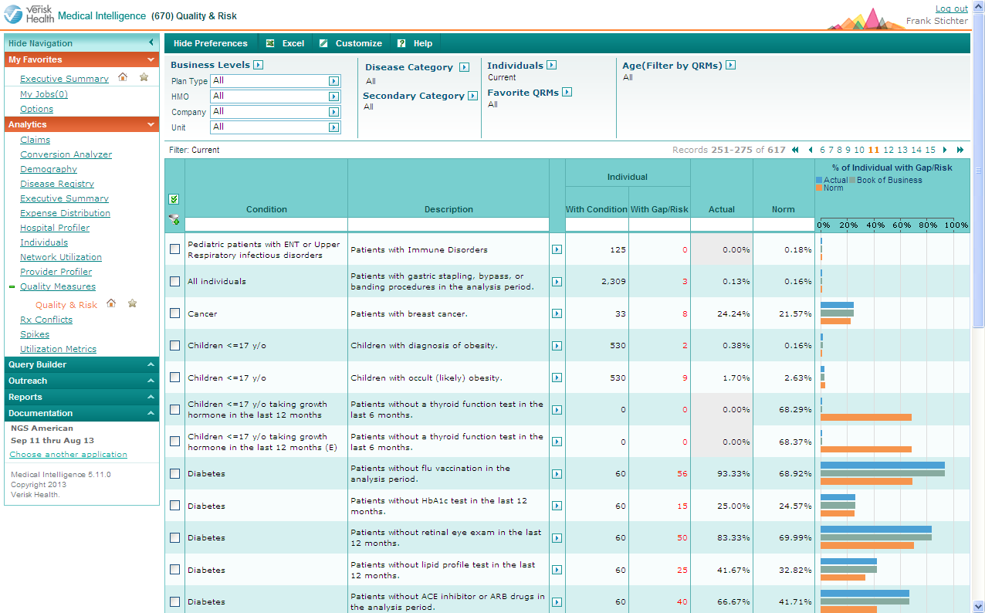

Those with a Gap Risk are not compliant with the Quality and Risk Measurement.

By utilizing an effective Disease/Risk Management program, clinical compliance is very achievable in a short period of time. This means more effective control on Chronic Conditions and lower costs.

Reporting can also identify compliance with Men’s and Women’s health screening and testing to assure compliance.
As a result in identifying the populations with Gaps in Care, targeted and effective education, communication, and wellness programs can be implanted to lower cost further.

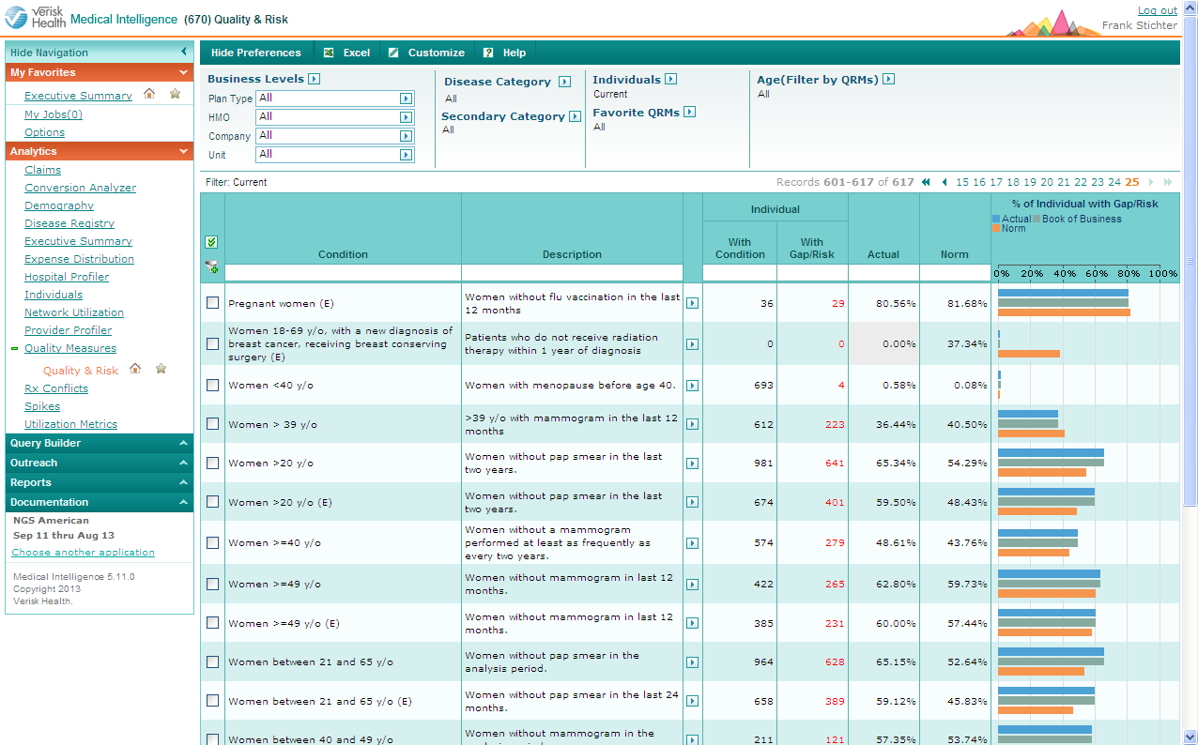

The Third Step – Strategic Implementation

Collaborating with a consulting partner who has the relationships, expertise, and experience is critical to successful implementation of any and all of these programs. One must have the ability to analyze and understand the impact of these programs as it relates to financial outcomes and employee goodwill, as well as the relationships with outside vendors in order to utilize Best In Class providers.

When done successfully, our experience has shown that potential annual savings can range from 12% to 22% of plan costs – without changing benefits or cost shifting to employees.

Whether your group is fully insured or partially self funded, or something in between, if there is the ability to gather documents and data, the opportunity to generate savings is real and full transparency is realized.

Which would your organization prefer?

Annual Increases or Annual Savings?

Premium Increases
(Rule of 72)

Current Costs

Cost Reductions

Frank M. Stichter, MHP

Mr. Frank Stichter is the Founder and Principal of Strategic Healthplan Consulting LLC. Working from his office in Crested Butte, he coaches, consults, and advises his clients to better manage their health plans. In this capacity, Frank works with clients to educate and inform them about innovative techniques and how to utilize them when working with their brokers.

Frank is a graduate of Western State College of Colorado. He has over 35 years’ experience in the benefits arena, including 14 years as President of his agency, Creative Insurance Resources. He went on to be Vice President of Group Benefits for the Hylant Group, as well as a Co-Founder and Partner of HyHealth – Hylant’s Wellness and Disease Management division. Frank’s experience also includes developing Association Plans for healthcare organizations across the country, as well as Community Based Health Plans.

Frank earned the Managed Healthcare Professional (MHP) designation through the Health Insurance Association of America. He is a member of the National Association of Life Underwriters and the National Association of Health Underwriters.

He has spoken numerous times on the subjects of Self Funding and Healthcare Risk Management programs at national conferences throughout the country, and has written a variety of articles and position papers on these topics as well.

